**SoftPro® Ambulating AFO**

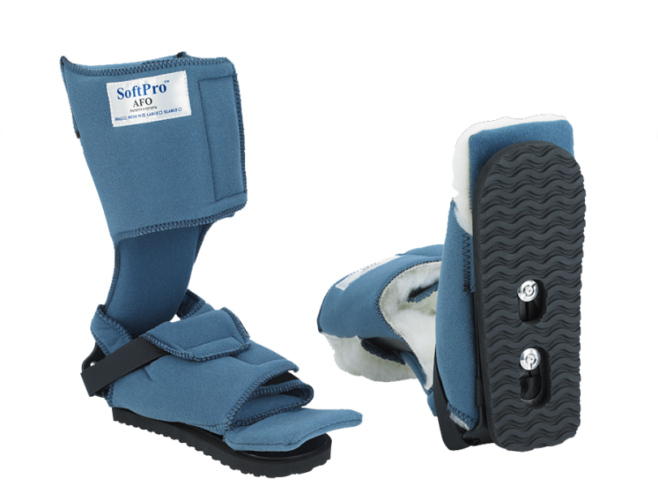

* **Effectively treats plantar flexion contractures**
* **Non-removable transfer pad**
* **Facilitates initial weight bearing and *assisted* gait training**
* **Available in smooth or fleece**

